11.1 Acids and bases
Name: ____________________ Class: ____________________ Due date: 11.12
1. Which substance is the most acidic? （ ）
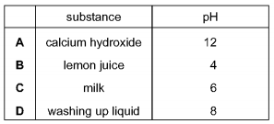
2. Different plants grow best under different pH conditions.
Which plant grows worst in acidic soil? （ ）
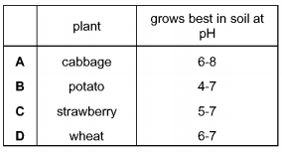

3. The graph shows how the pH of soil in a field changes over time.
At which point was the soil neutral? （ ）
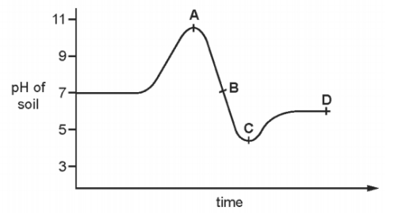

4. Which of the following solution has the highest concentration of H+ ? （ ）
A. HCl(aq) with ph of 2 B. H₂SO₄ with ph of 3 C. NaOH with ph of 9

5. Which of the following solution has the lowest PH
A. HCl with 1mol/cm3 concentration of H+
B. H₂SO₄ with 0.002mol/dm3 concentration of H+
C. NaOH with 0.00002mol/dm3 concentration of H+
D. HNO₃ with 0.3mol/dm3 concentration of H+

6.Which of the following solution shows the lowest acidity? （ ）
A. HCl solution with ph of 2
B. CH₃COOH solution with ph of 3
C. Na₂CO₃ solution with ph of 8
D. NaOH solution with ph of 14

7.(Extension).
A sting from insect X has a pH of 6 and a sting from insect Y has a pH of 8.
The table shows the pH of four substances.
The effect of acidic substances can be canceled by substance with ph higher than 7
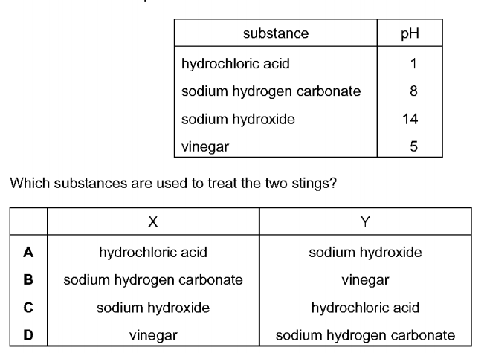
Which substances are used to treat the two stings? （ ）

8. Solution A has a higher concentration of H⁺ ions than solution B does.
Which has a higher pH, A or B?

9. Solutions of acids X and Y have the same concentrations.
X has pH 2.5. Y has pH 5.3. Which one is a weak acid?

10. A solution of a strong acid has a pH of 2.
How will the pH change when you add more water? Explain your answer.

11. Please complete the reaction for dissociation of the following acids
（The first blank is for the symbol , the last is for the product)
(a) HNO₃ H+ +
(b) H₂SO₄ 2H+ +
(c) HCl H+ +
(d) H₂CO₃ 2H+ +
(e) CH₃COOH H+ +

